Welcome to the First Day of School!
Miss. Schul, 3rd Grade, Room 8
Welcome! Today starts a brand new adventure for you! I am so excited to be your 3rd grade homeroom, math, and science teacher for the 2017-2018 academic school year. Your reading, and social studies teacher will be Miss. Lee, who is across the hallway from us. Get ready for a fun filled day with lots of learning about our classroom, rules, expectations, and your teacher- me!
In this class, we throw confetti like kindness! This is our class moto for the school year. All year long we will throw kindness and be posting it on our bulletin board in the hallway to be on display to the whole school.
Class Dojo Points!
We will use class dojo. You will earn points through the week,
and be able to cash them in every Friday
for “cash” to later redeem for prizes!

Center Rotations “THEG”
In math and science, we will use centers. We will have
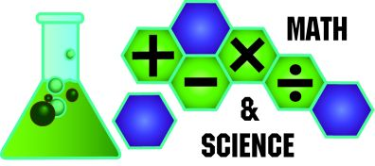
a mini lesson first that I will teach, and then you will go
through 4 centers: T teacher’s choice, H hands on,
E extension activities, and G group work.

Behavior Scale: Every student will follow this.
Step 1: Identify the problem and how to fix it
Step 2: Conference with Miss. Schul
Step 3: Conference and consequence with Miss. Schul
Step 4: Time to talk to parents/guardians
Step 5: Mrs. Castor in the Principal’s office

Once all of the students have arrived please meet me up at the carpet with your smile, and pencil! We will go over our daily schedule, get to know one another and talk about our classroom. I look forward to getting to know you!
Sincerely,
Miss. Schul

