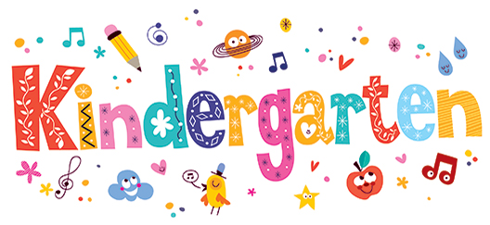
Dear Kindergarten Parents,
I am so excited to be your child’s Kindergarten teacher for this 2017-2018 academic year. By the end of the year your child will make tremendous growth and progress, learning many new things every day! Each student will be at a different level when they come to school this fall- and that is okay! Throughout the entirety of the year I will be using developmentally appropriate practices. This means that I will be designing my lesson plans, class activities, classroom set up and so on, based around what is appropriate for a five-year-old. There is great importance and significance of this because it will focus on the student’s social/emotional, physical, and cognitive development. Entering Kindergarten, all your children are still in a critical stage of development. I will foster this development and provide them with appropriate, research-based lessons.
This is always the first question I get from parents: is my child still going to have time to be a five or six-year-old? Absolutely! Play is an important part for Kindergarten, as it still is an enriching time for the students. Much of what they learn and discover is still done through play, and also exploration. Through play, your child will still develop literacy skills, as they will be conversing with other classmates. Think your child is shy? Not to worry! As the teacher I will always be walking around the room engaging all students with one another, and also guiding discussions to go deeper. According to research skills ranging from social, cognitive, physical, and emotional, are all supported through play and is a critical part to their day. You can expect your child to only have 1 minute of homework per night. (We will talk about this later ) Encourage your children to still go outside and play, go to the neighbors house and play. Any way they can engage in play and free choice of exploration, is going to benefit your child.
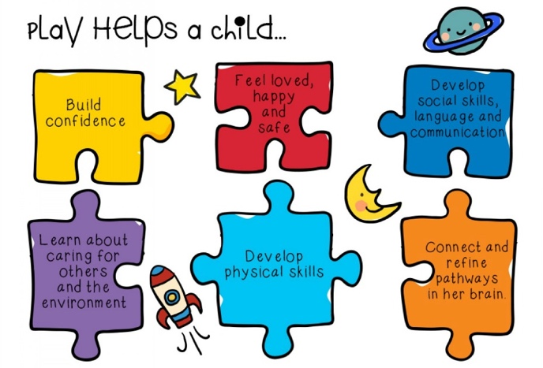
I always encourage my parents to always feel free to reach out to me at any point about any concerns, and questions about why we are doing certain things in class. I am always more than happy to explain my techniques to parents! I hope to have a great year with both you and child!
Sincerely,
Miss. Annika Schul
Kindergarten Teacher

