Help in our classroom with school sponsored trips and activities!  Each year I get many parents volunteering to come into the classroom to help! If you wish to do this, you must obtain all of your clearances to be let into the school. Please contact me for more information!  Other ways to get involved if you can’t easily obtain clearances?  Donate supplies! Continually throughout the school year we will need donations for activities. Please look at my newsletter for more details or feel free to contact me!  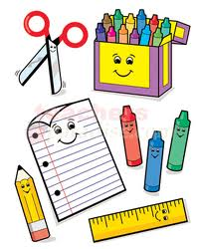 | Programming!  Each year I always add in a section on programming that I recommend for your child before/after school. Children can benefit from these programs and you should not hesitate to try them out! Below is a list, including contact information, of different before and after school options for your family to consider if needed.  State College YMCA: Offers before and after school programs  (814) 237-7717  The Goddard School: Offers before and after school programs  (814) 237-1160  Bricks 4 Kidz: Offers before and after school programs  (814) 584-2211  ABC Children’s Center: Offers before and after school programs  (814) 238-6510 | Miss. Schul  Kindergarten-2nd Grade Learning Support  State College Area School District  2018-2019  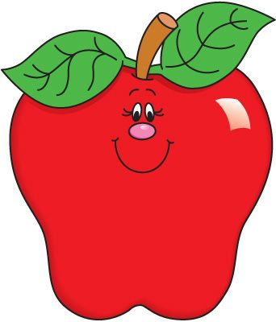  A Guide for Parents:  Educational Activities and Trips!
What is an educational activity and/or trip?  An educational trip and/or activity is one in which there is a benefit to your child! Giving your child as many real world experiences, the better. This prepares them for so much more and really helps their learning in the classroom setting as well.  Educational activities can look different for every family and can be tailored to your family’s interests! These activities are anything that supports their development and strengthening of knowledge.  Educational trips can also look very different for every family, being tailored to every family’s interests! These trips can be anything that promotes a new experience or reinforces a concept that they have learned or are learning in school.  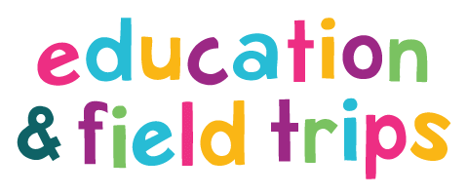 | 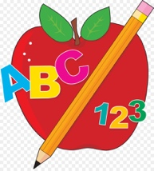  Our current goals and standards!  It is not required that you do something with your child directly related to our current goals and standards, but the standards I use for all of my students are provided below! (Please feel free to contact me regarding more specific ideas regarding to IEP goals for your child).  Reading: Standard - CC.1.1.K.E  Read emergent-reader text with purpose and understanding.  Math: Standard - CC.2.1.1.B.3  Use place value concepts and properties of operations to add and subtract within 100.  Exploration/Play: Standard - AL.1.K.A1  Explore and ask questions to seek meaningful information about a growing range of topics, ideas, and tasks.  Science: Standard - 3.1.K.A1  Identify the similarities and differences of living and non-living things.  Social Emotional: Standard - AL.3.K.A1  Use music, art, and/or stories to express ideas, thoughts, and feelings. | Free Educational Related Activities/Trips to Do In State College!  The Arboretum  Millbrook Marsh Nature Center  Discovery Space of Central PA  PA Military Museum  Tussey Mountain  Schlow Centre Region Library  Tom Tudek Memorial Park  Spring Creek Canyon Trail  Penn’s Cave  Penn State: Museum of Art and All Sports Museum  