Additional Resources  Career Link (814) 272-5465  Centre Peace (814) 355-6768  Child Care Information Services (814) 231-1352  Community Help Center (814) 237-5855  Department of Public Welfare (800) 355-6024  Faith Center (814) 355-2238  Interfaith Human Services (814) 234-7731  Salvation Army (814)861-1786 | Additional Resources (Cont.)  Strawberry Fields (814) 234-6023  Centre Volunteers in Medicine (814) 231-4043  Community Resources (800) 494-2500  County Assistance Office (814) 863-6571  Food Pantries of Centre County (800) 822-2610  State College Food Bank (814) 238-8283 | 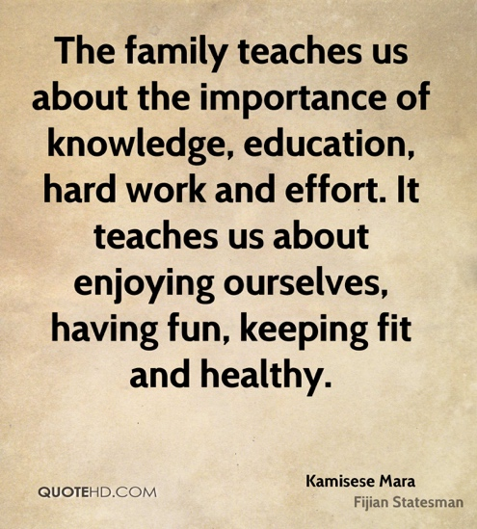 | Local Agency Brochure
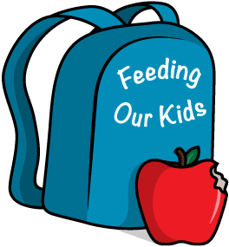  HOPE Initiative  The Centre County HOPE initiative is based around prevention and education on the opioid and heroin crisis. Many resources and outlets for help are provided. |  | Kaleidoscope Family Services provides specialized clinical and therapeutic services directly to individuals. They also provide education-system staffing services.  KFS Behavioral Therapeutic Services  KFS Autism Services  KFS Intellectual and Developmental Disabilities Resources | Miss Schul  2018-2019  State College Area School District: Centre County
 | 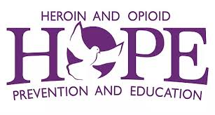 | 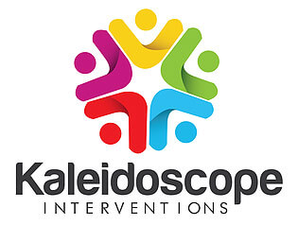

Dear Parents and Guardians,  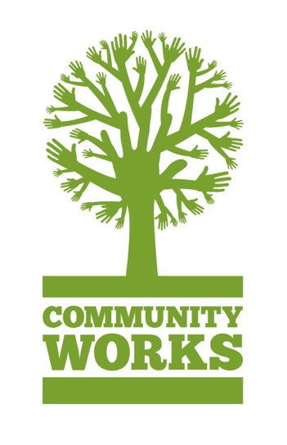  In this brochure, you will find more information regarding organizations within our community. All of these resources are available through Centre County! | State College Area YMCA  The SC Area YMCA offers financial assistance, along with various beneficial programs. Eligible families will receive aid to participate in membership programs, such as child care, after school care, health and wellness, swim lessons, and leadership opportunities. These are just some of the many benefits provided by our YMCA! | 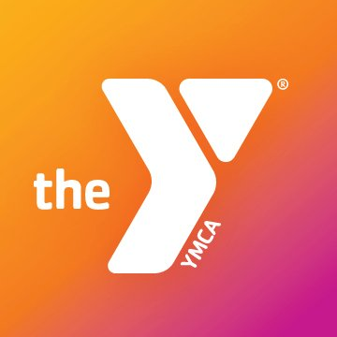 |  | Pennsylvania Assistive Technology Foundation  The foundation’s goal is to help provide financial assistance to ensure that disabled individuals, as well as elderly individuals and those in need, receive the technology they need.
Schlow Centre Region Library  The library is a free resource to those in Centre County. Not only does it promote literacy, but it provides books to the whole family to be utilized at home. | 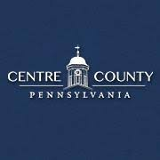 | Centrecountypa.gov  This website offers a comprehensive list of various resources regarding numerous topics for the whole family! This website also includes detailed instructions on how to get in contact with the state if you, or your family, is in need of insurance. |  | The Backpack Program of the Centre County YMCA provides take home food to students on the weekends at no extra cost to families. The program is sponsored by Penn State University.
 |  |  | Centre County Resources Guide:  The link below provides a surplus of resources for health, wellness, and financial and academic resources!  https://centrecan.org/wpcontent/uploads/2017/07/Centre-County-Resource-Guide.pdf | 